Refining Your Results

**Using String Patterns and Ranges**

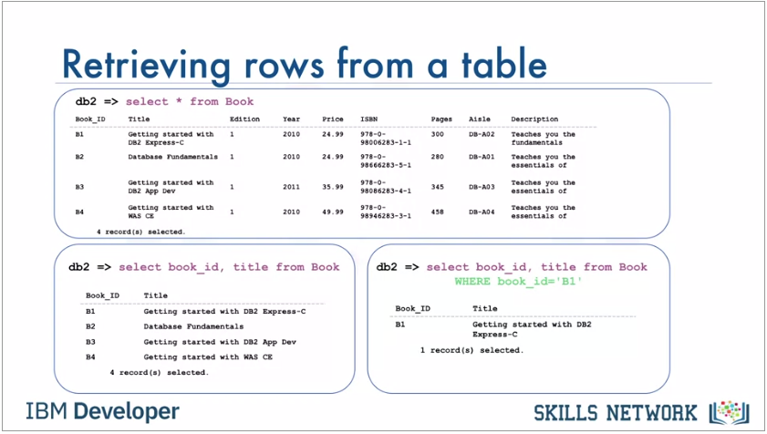

* The main purpose of a database management system is not just to store the data, but also facilitate retrieval of the data. In its simplest form, a SELECT statement is select * from table name. Or we can select book_id, title FROM book. Or we can restrict the result set by using the WHERE clause. But what if we don't know exactly what value to specify in the WHERE clause?

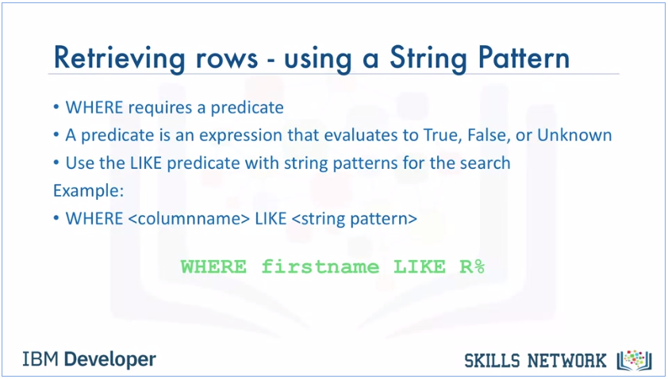

* If we can't remember the name of the author, but we remember that their name starts with R, we use the WHERE clause with the like predicate.
* The percent sign is used to define missing letters. The percent sign can be placed before the pattern, after the pattern, or both before and after the pattern. In this example, we use the percent sign after the pattern, which is the letter R. The percent sign is called a wildcard character. A wildcard character is used to substitute other characters. So, if we can't remember the name of the author, but we can remember that their first name starts with the letter R, we add the like predicate to the WHERE clause.

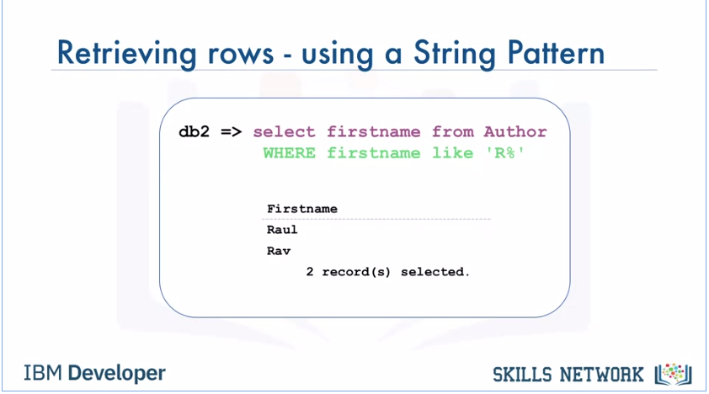

* This will return all rows in the author table whose author's first name starts with the letter R.

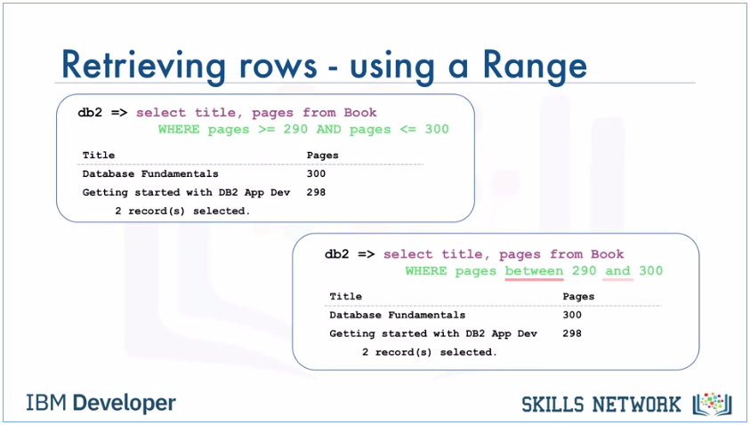

* Both statements’ result set are the same, but the second statement using “BETWEEN - AND” is easier and quicker to write.

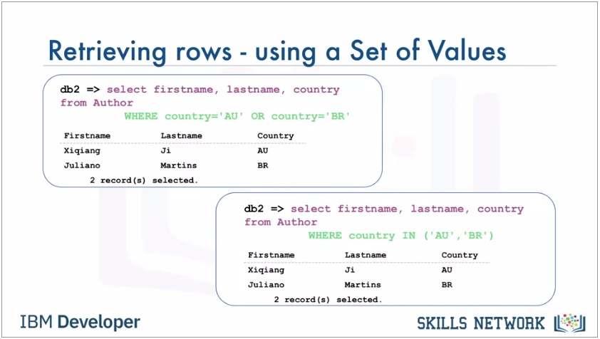

* Both also return the same result, but the second statement with the IN operator allows us to specify a set of values in a WHERE clause.

**Sorting Result Sets**

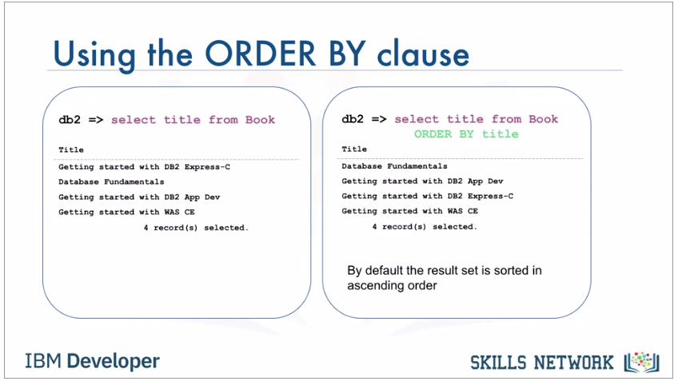

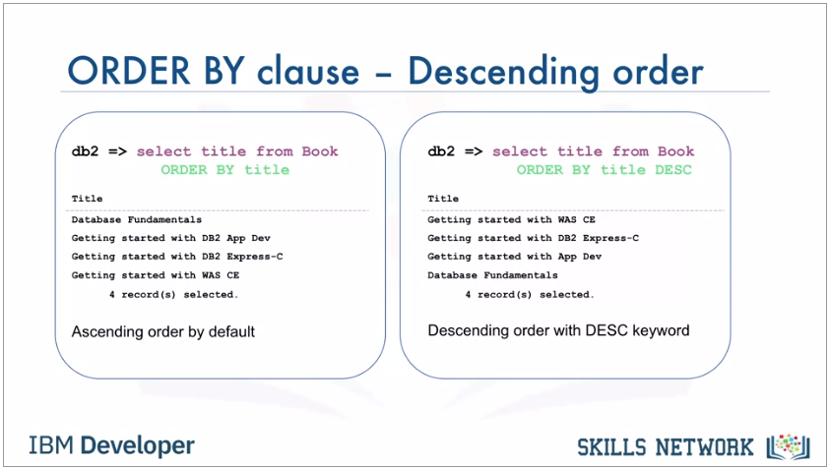

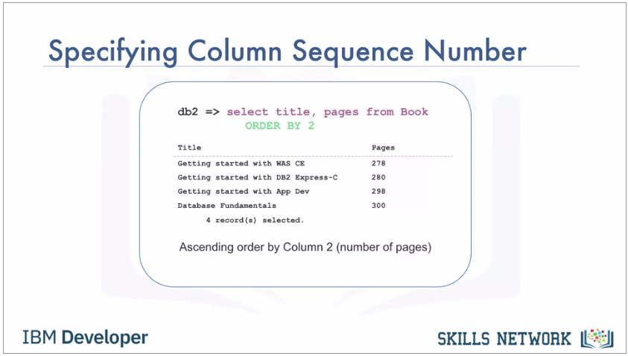

**Grouping Result Sets**

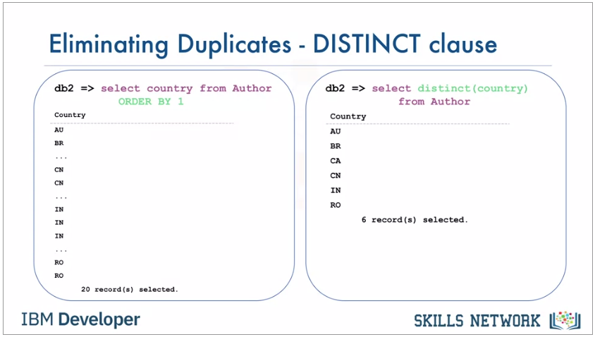

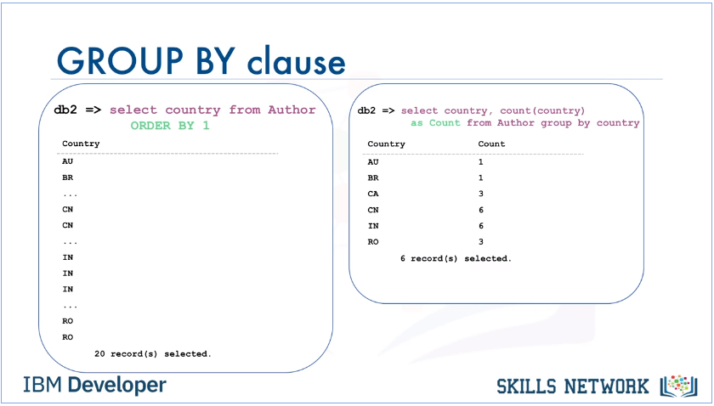

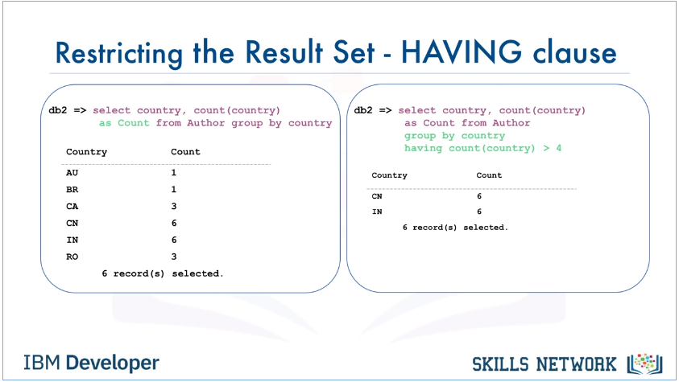

* The "having" clause is used in combination with the "group by" clause.
* It is very important to note that the "where" clause is for the entire result set, but the "having" clause works only with the "group by" clause.

To check if there are more than four authors from the same country, we add the following to the select statement, having count country greater than four. Only countries that have five or more authors from that country are listed in the result set. In this example, those countries are China with six authors and India, also with six authors. Now you can explain how to eliminate duplicates from a result set and describe how to further restrict a result set. Thanks for watching this video.